Github Account:

<https://github.com/ChhornKakada/Intenet_Programming/tree/tp14>

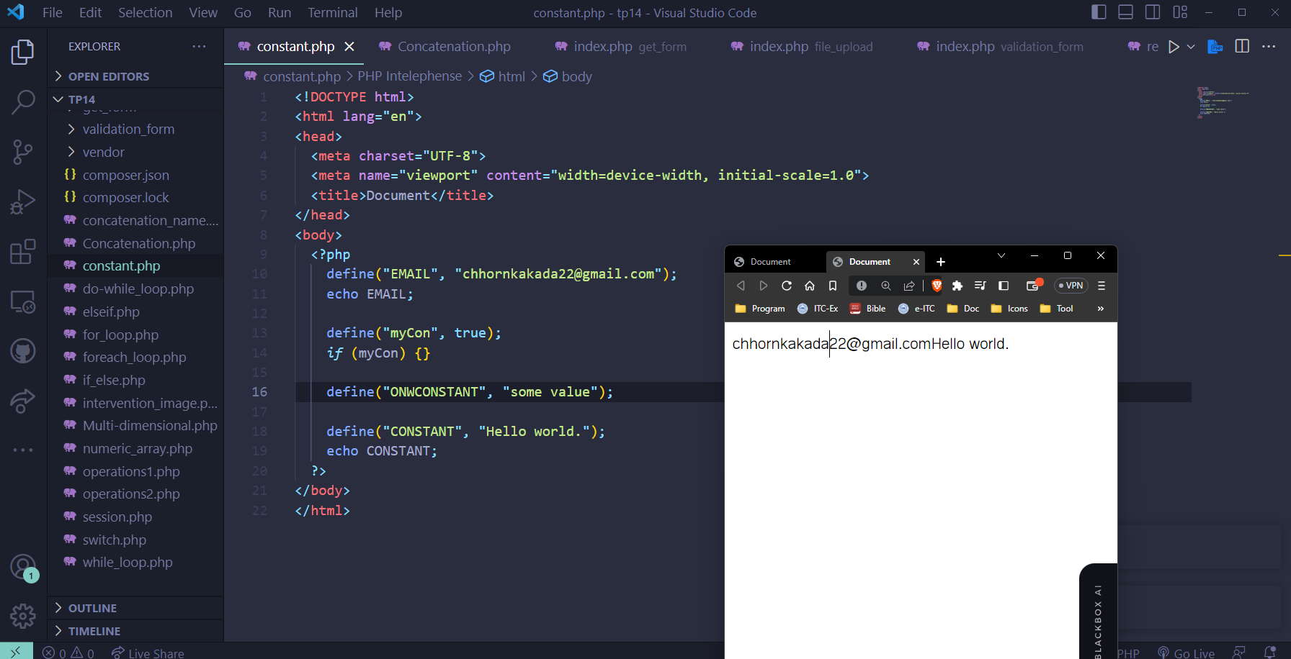

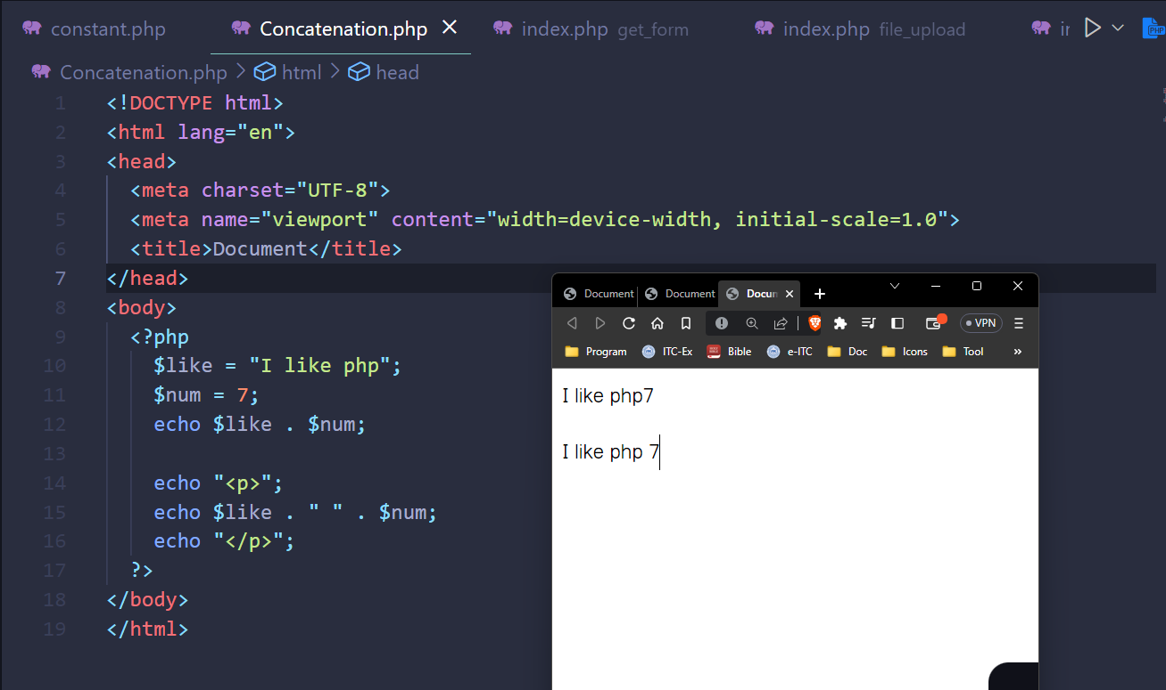

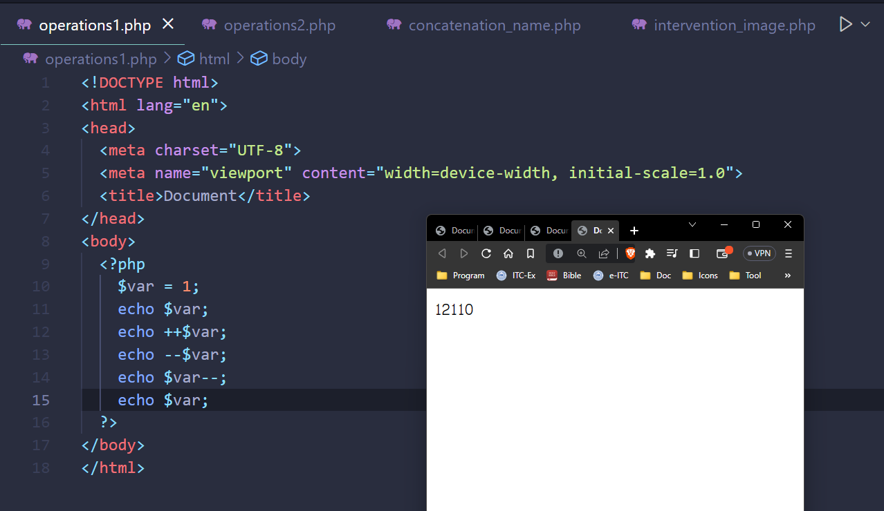

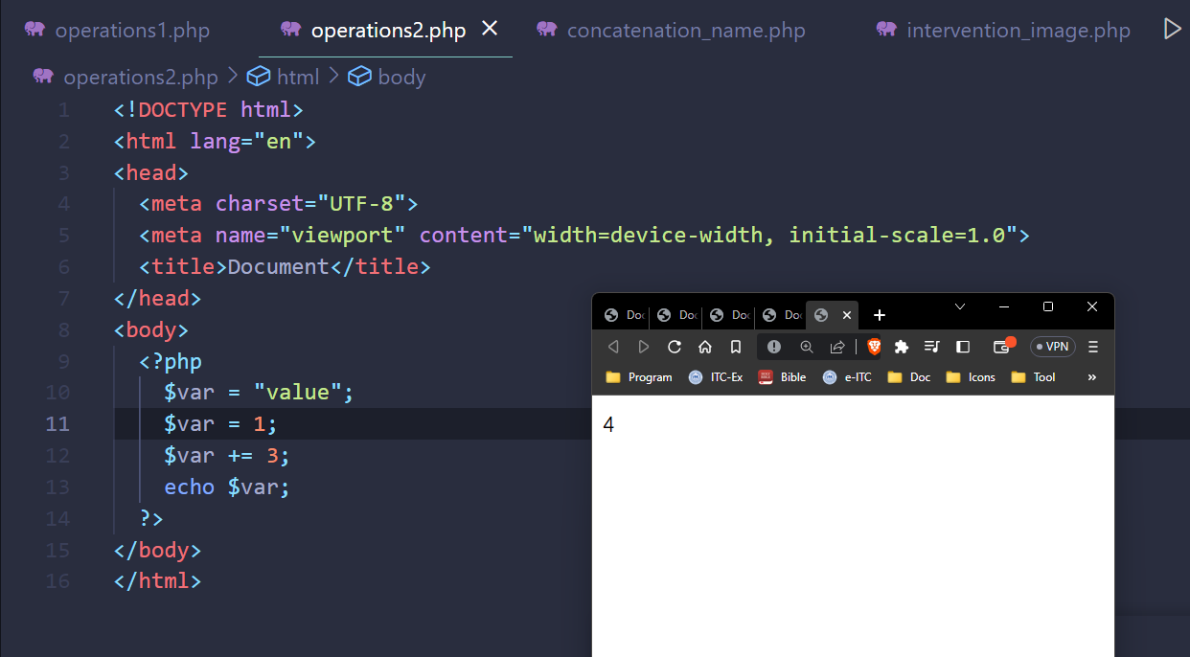

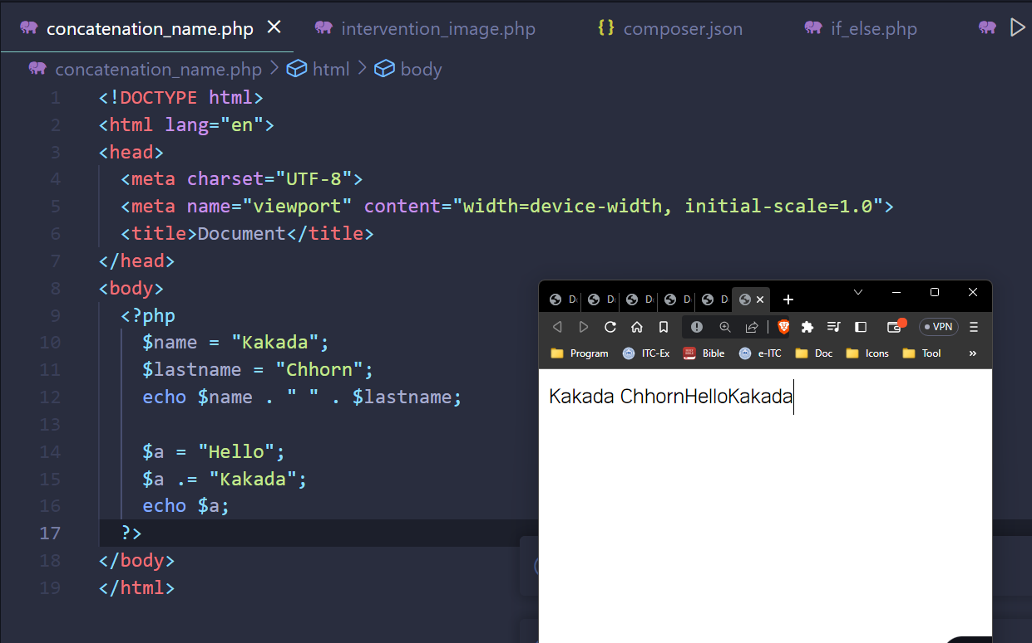

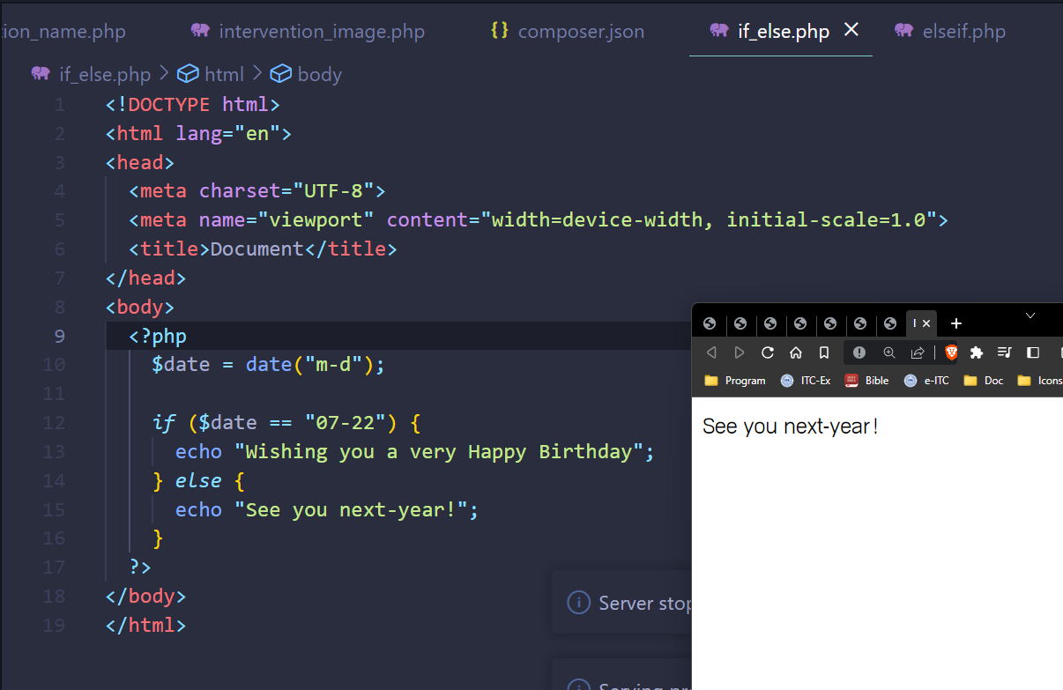

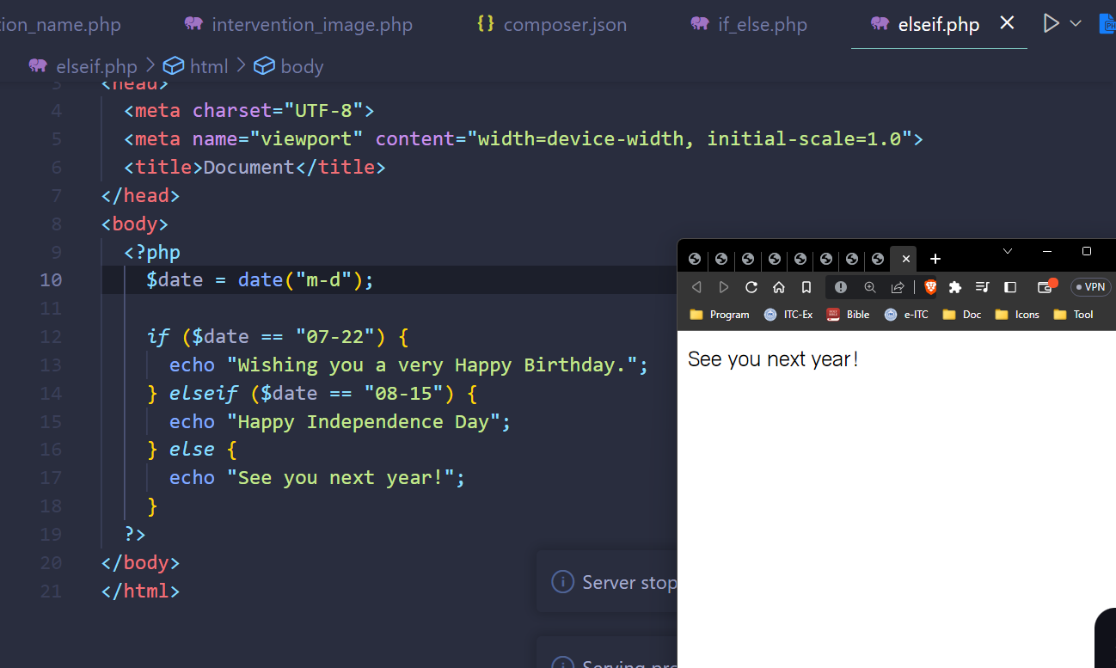

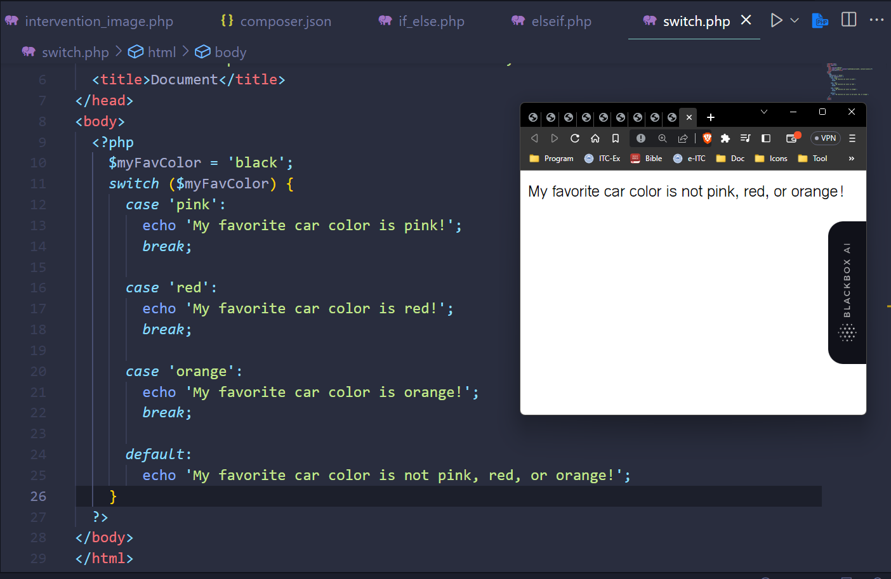

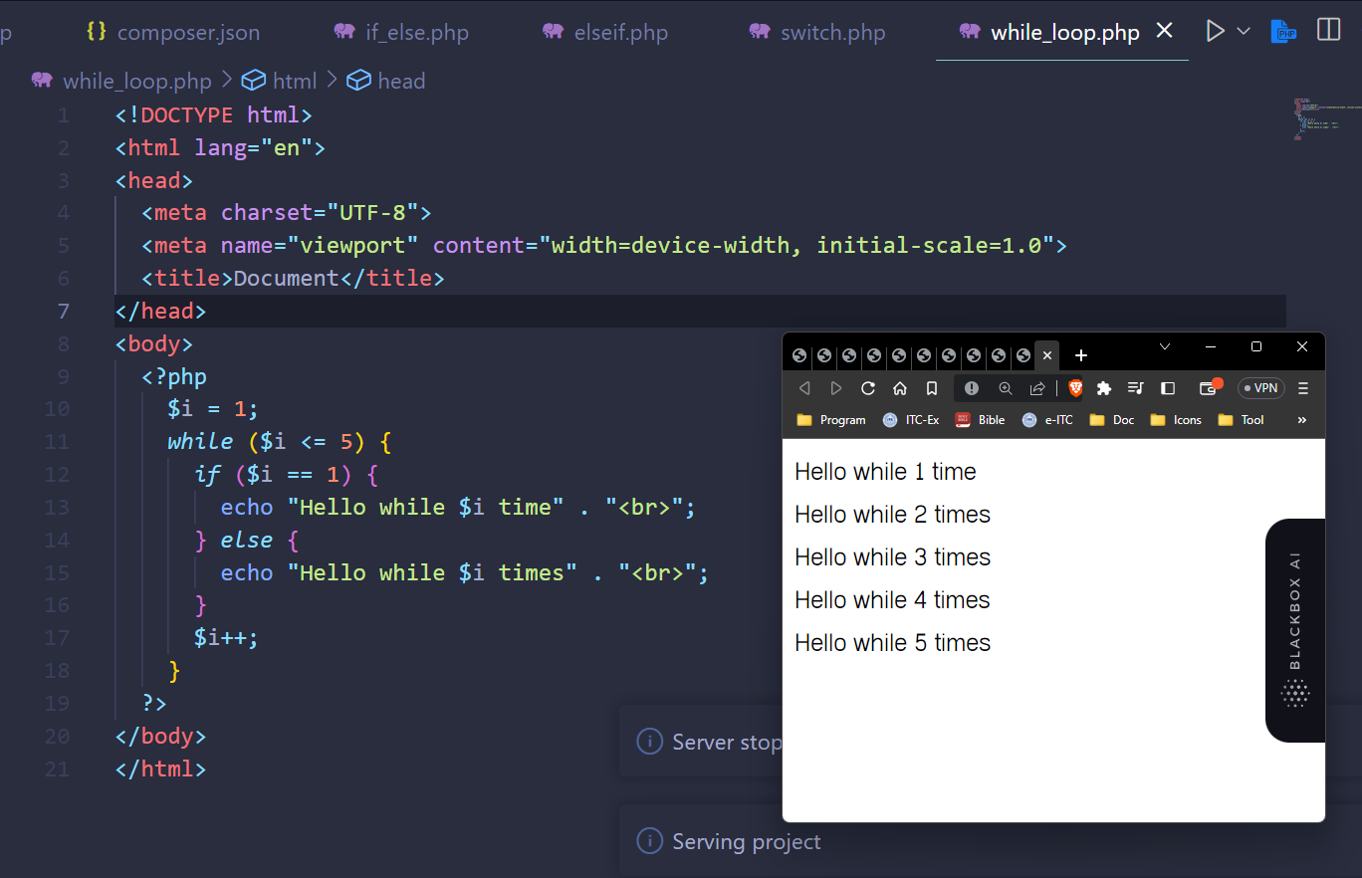

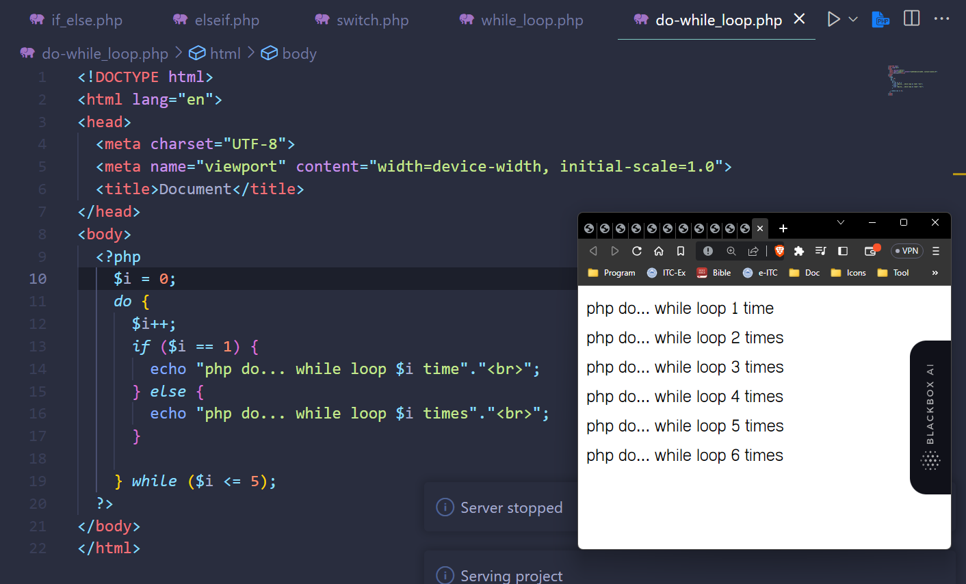

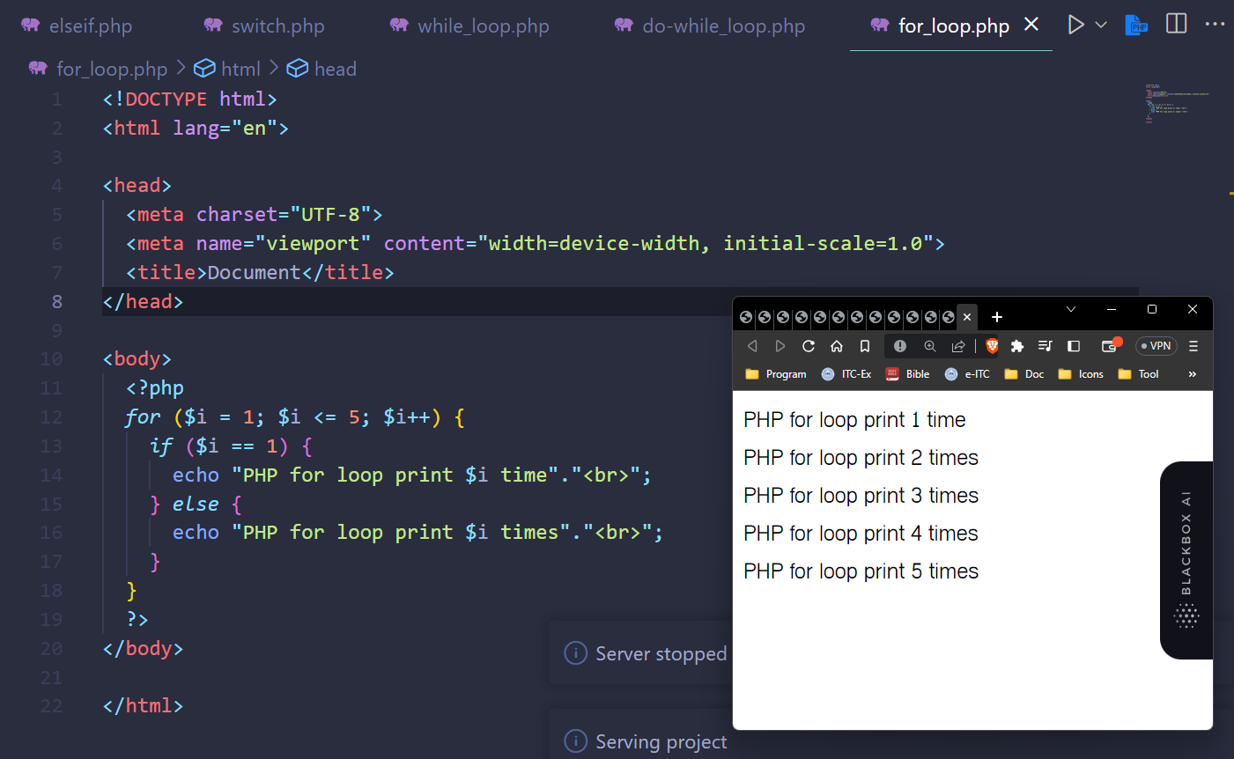

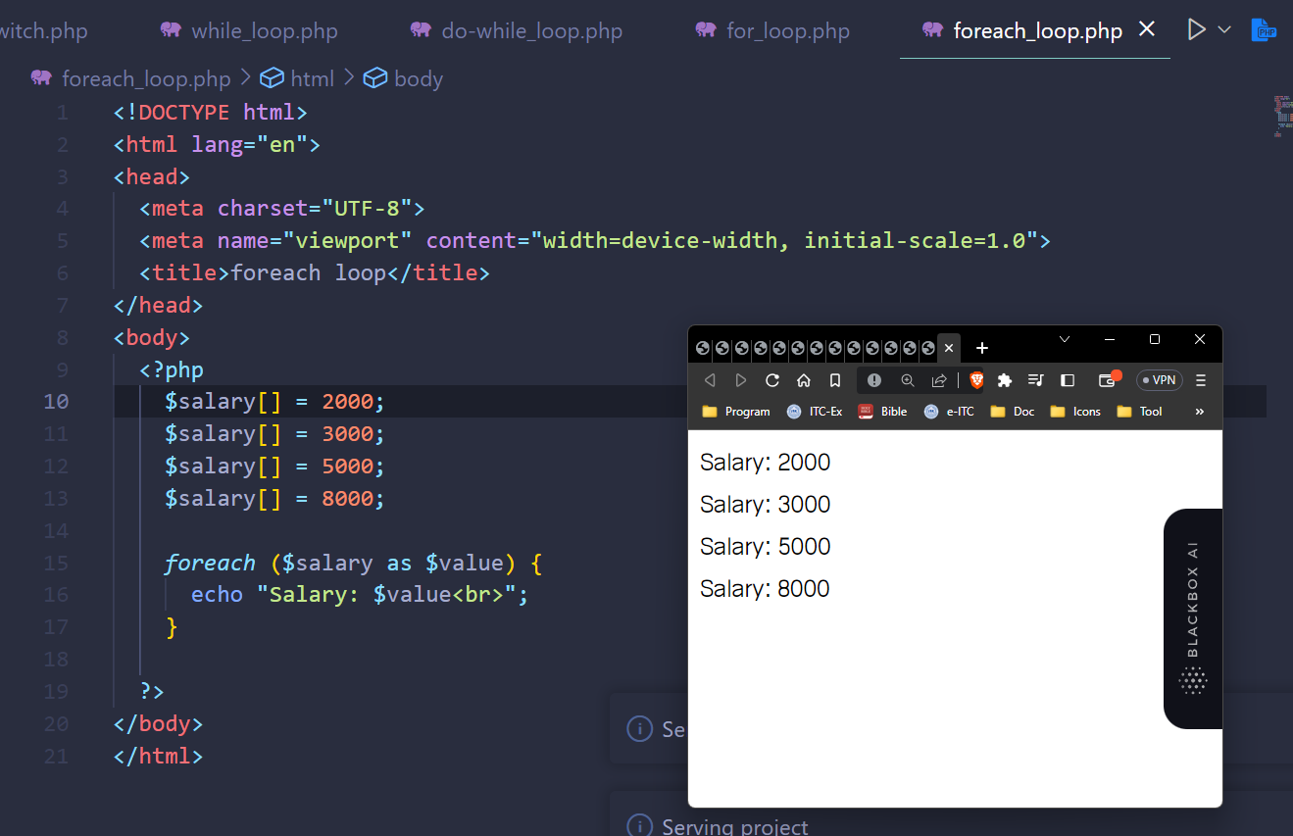

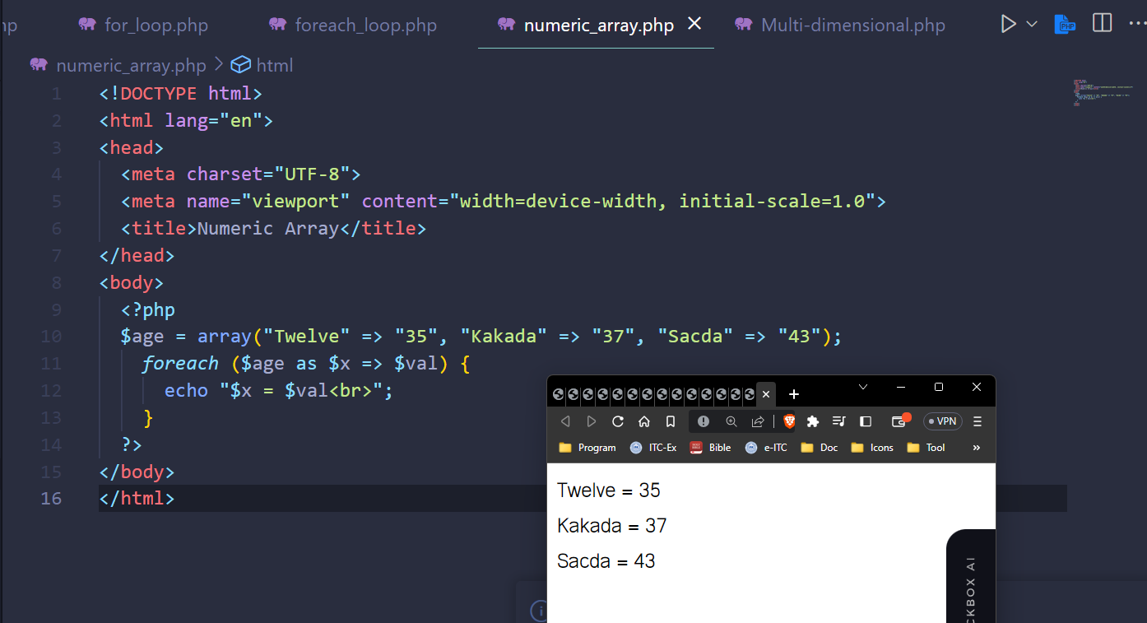

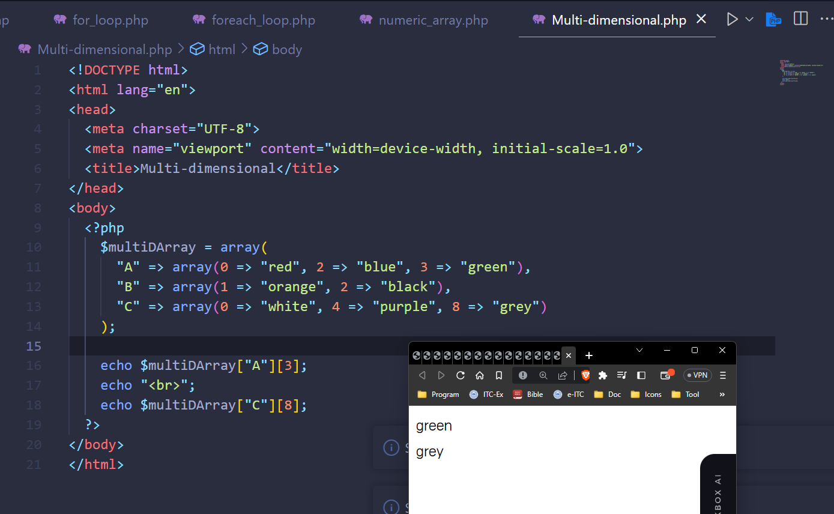

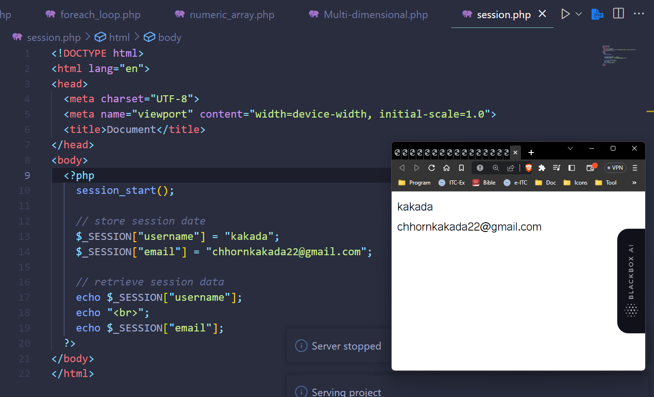

# Form POST

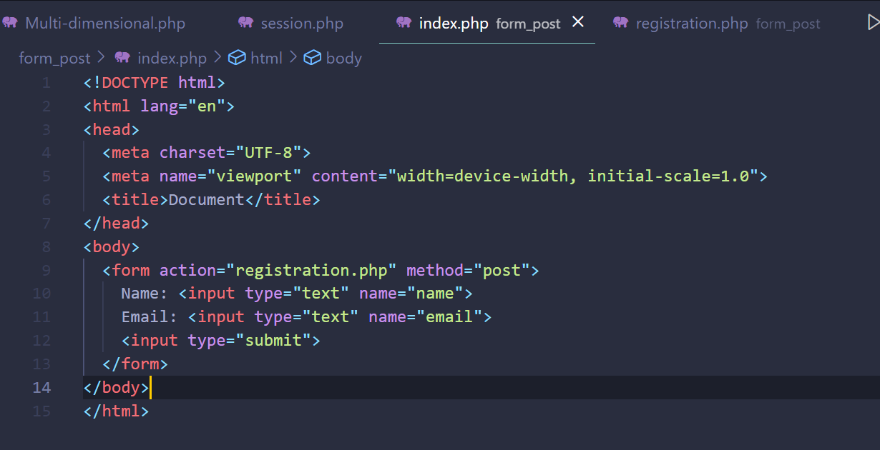

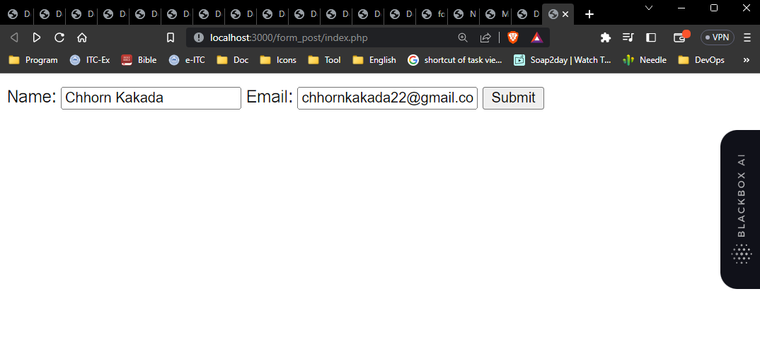

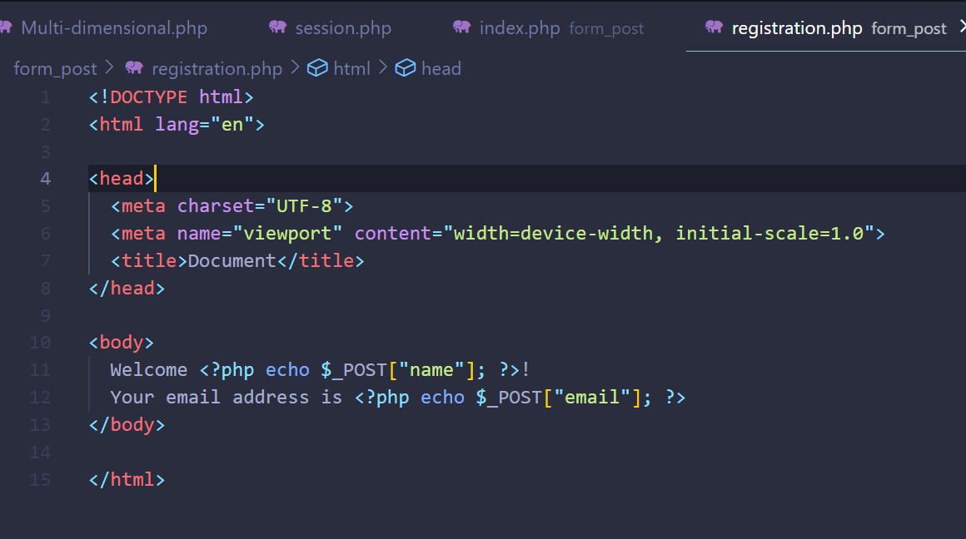

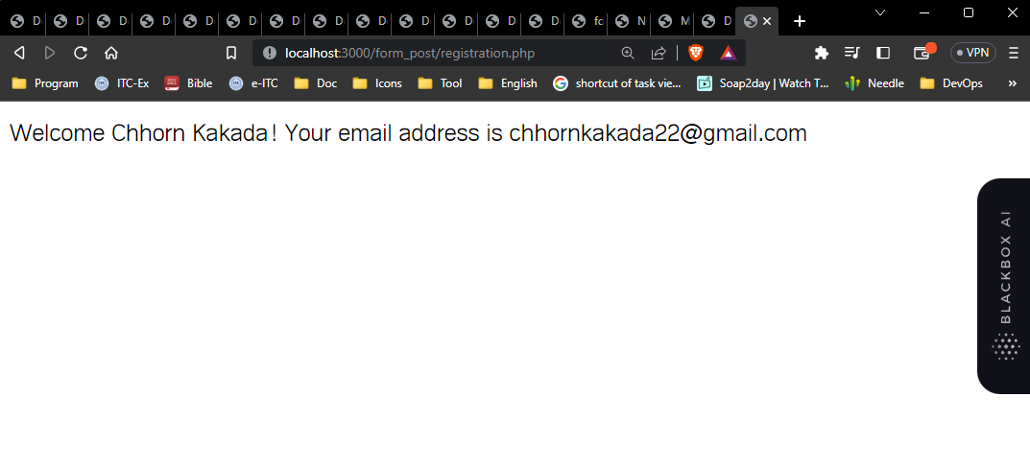

# Form GET

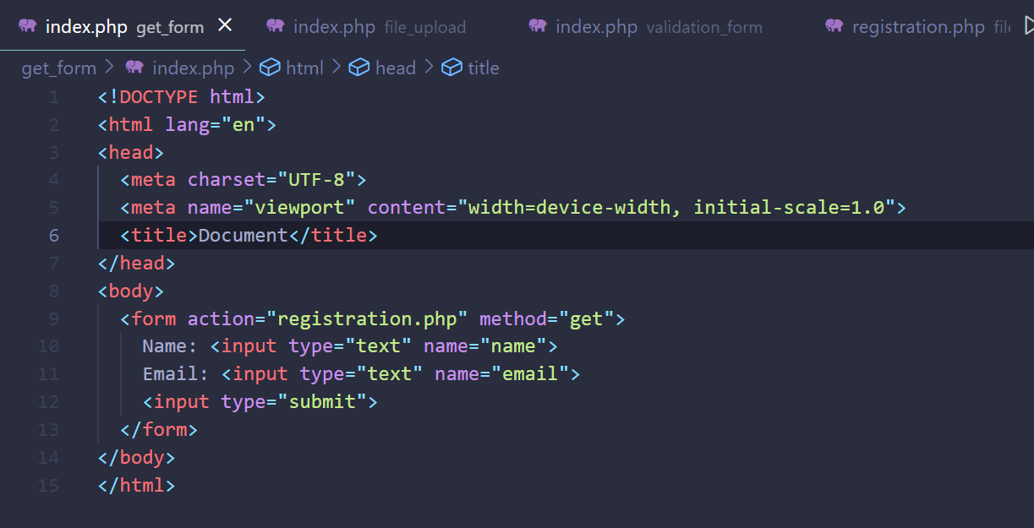

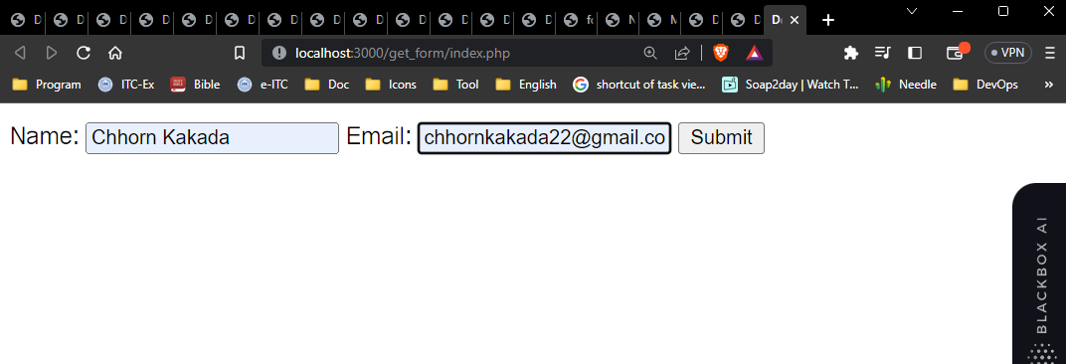

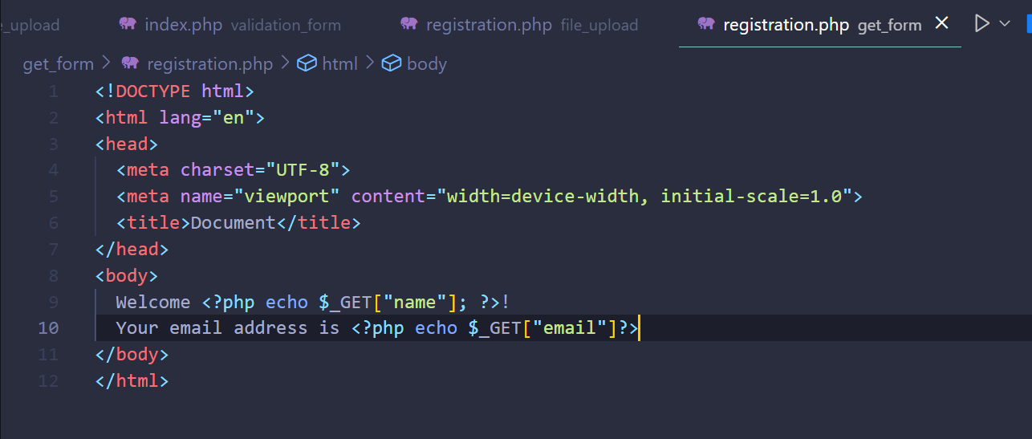

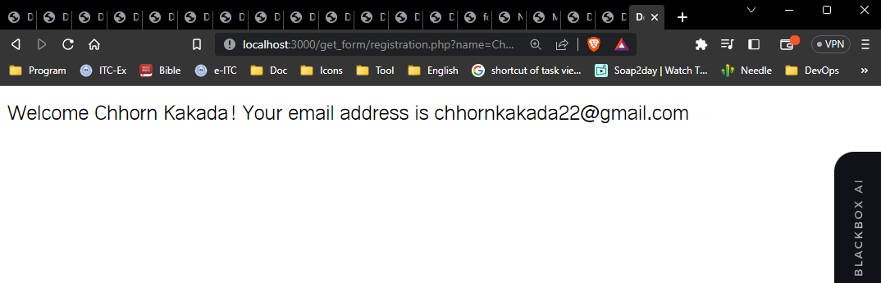

# Validation form

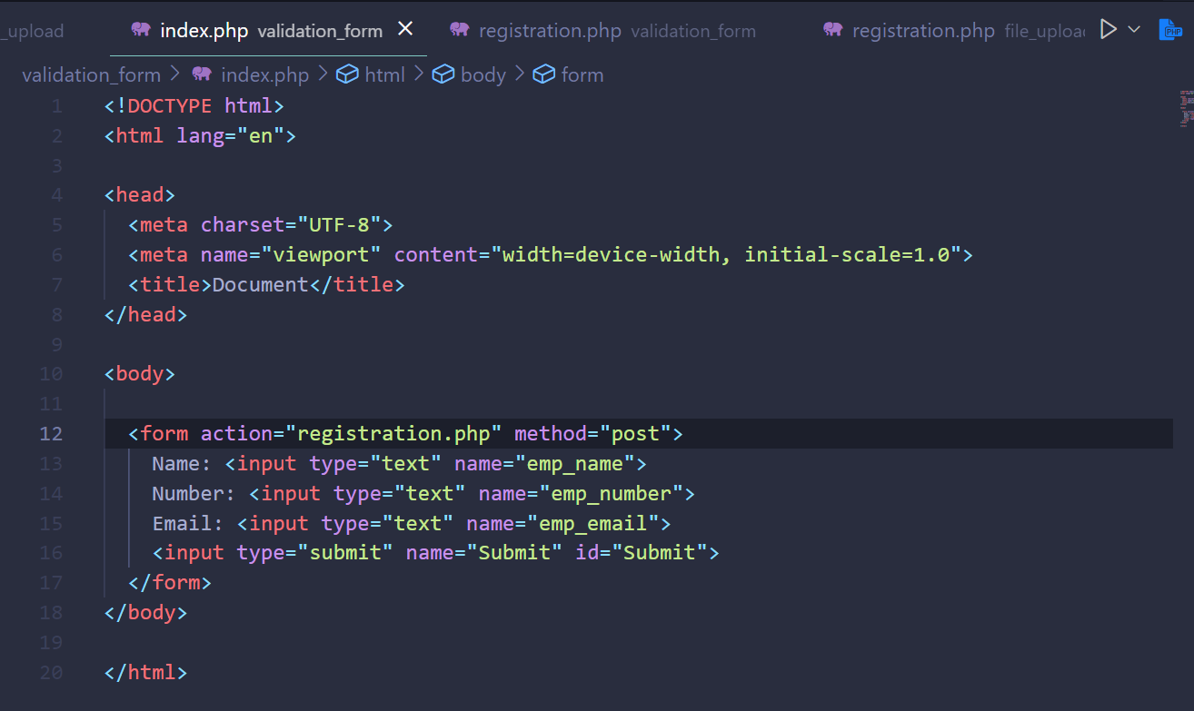

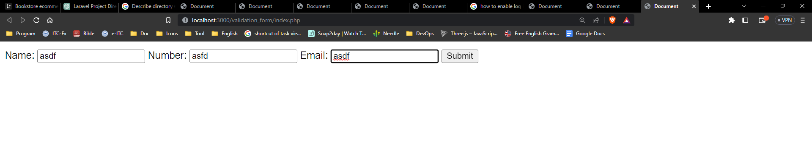

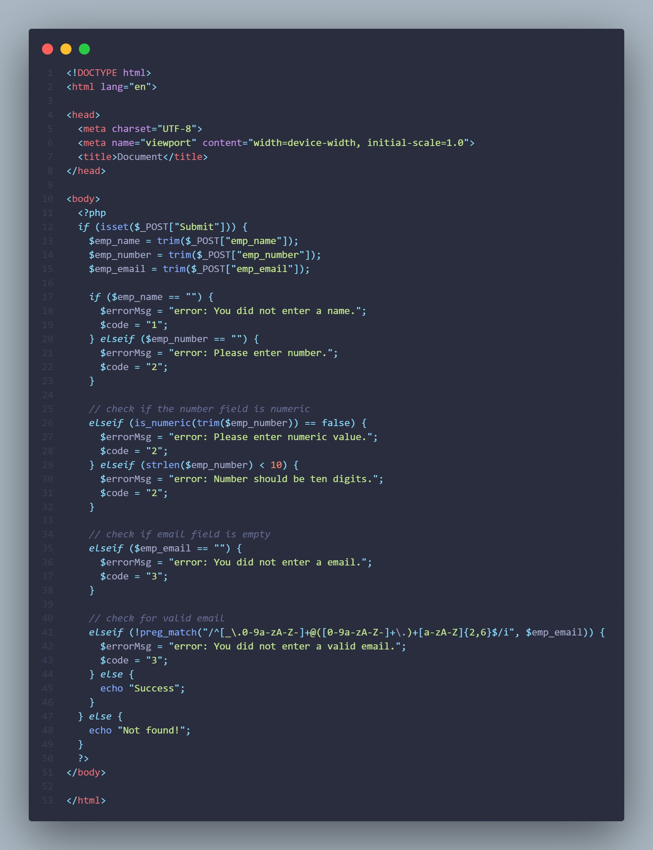

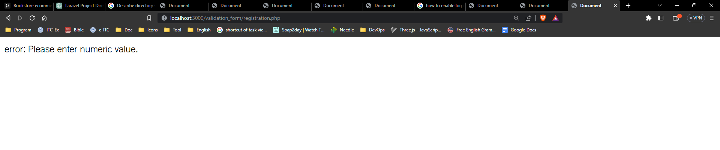

# Upload-file form

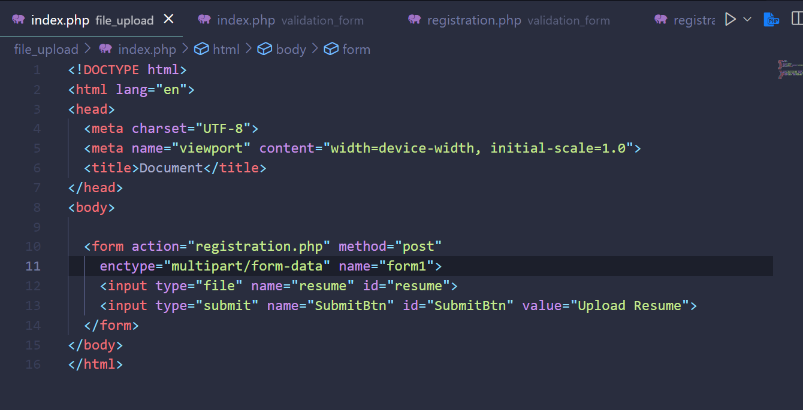

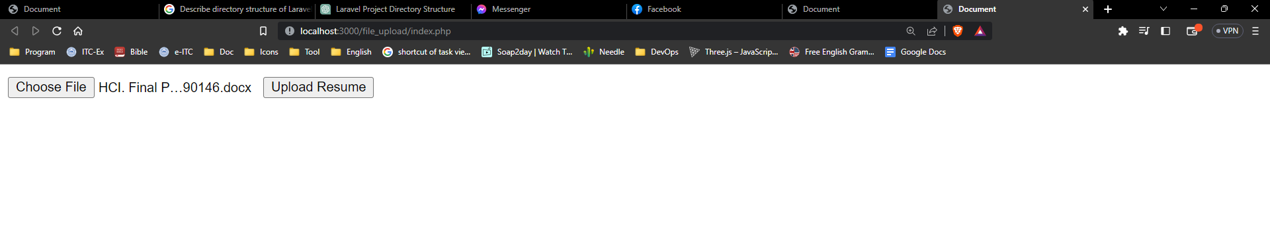

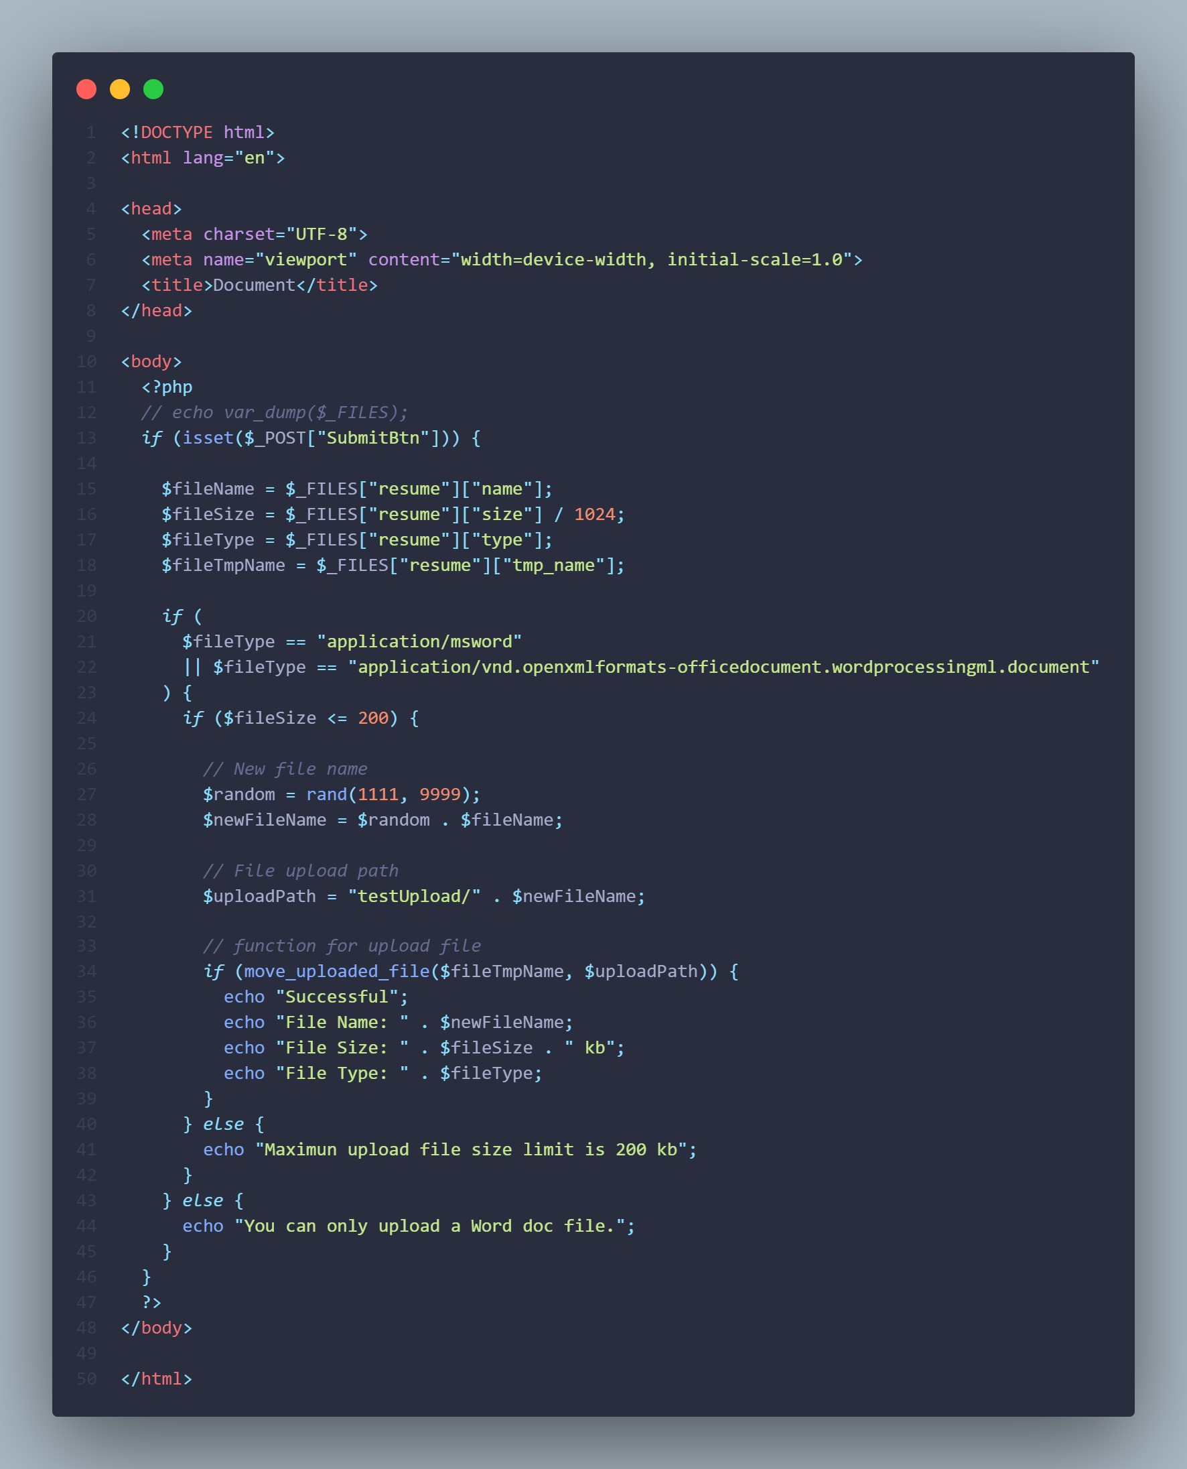

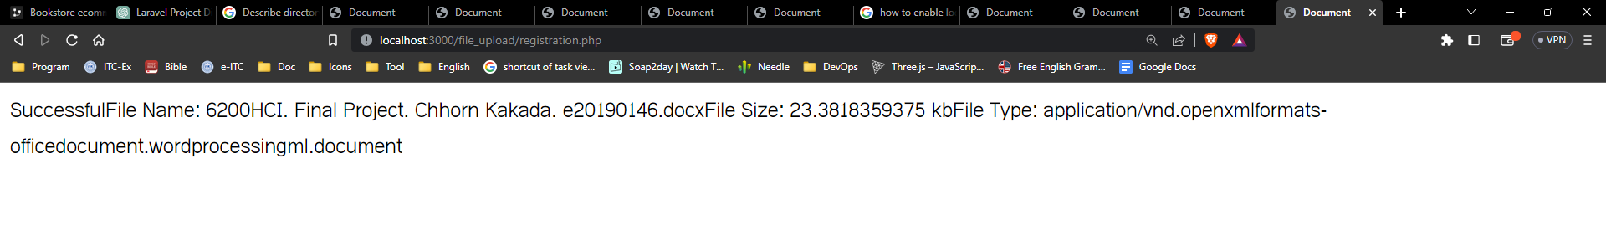

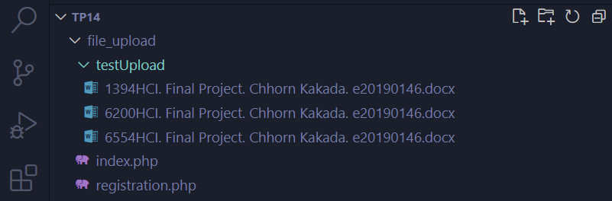

# Download and Installing composer

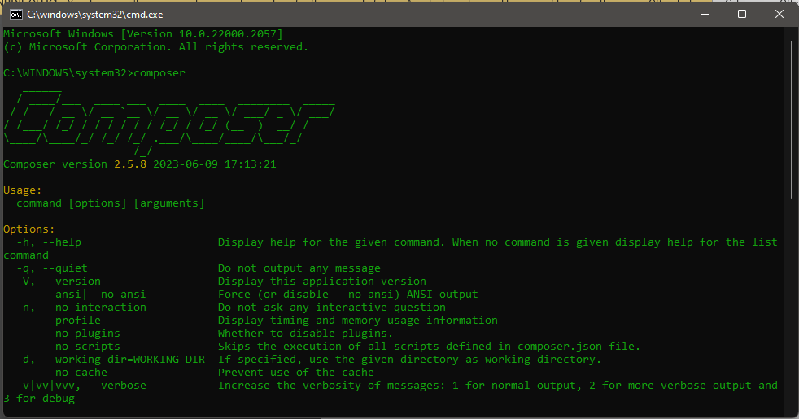

# PHP Composer

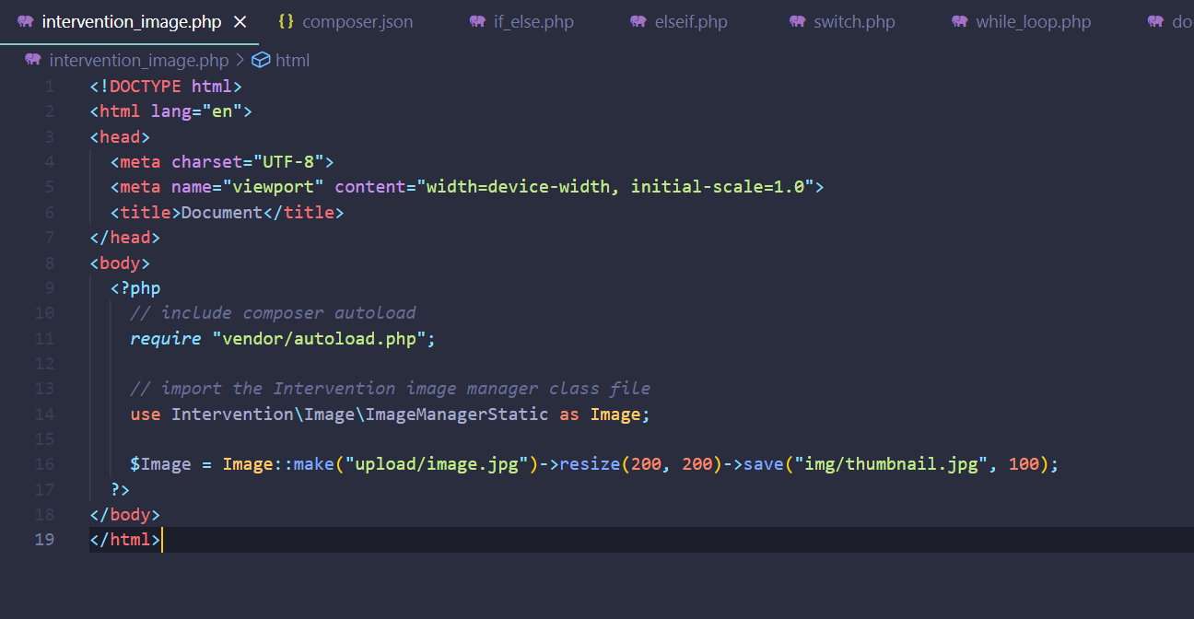

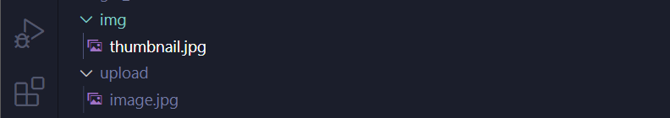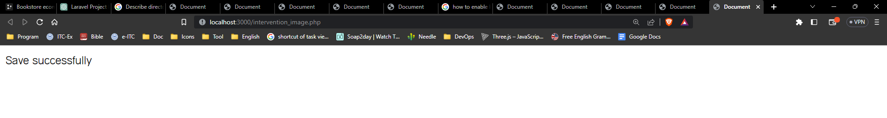

# Describe directory structure of Laravel project

**app** - most imp folder

**console**

**kernel.php**- any commands you can make

**exception**

**handler.php**- you can make handler, we can define error as a handler but as a beginner no need.

**Http**

**controllers** - default controller.php file has base controller

**middleware** - work as guards, if we can give access to them or not.

**Kernel.php** : middleware can use them. every path are declared them.

**Models**:

**User.php**: default model

**providers**: it will provides all services

**bootstrap**: laravel application speed up using this.

**app.php**: all apps are them

**config**: every configuration are there. mail, hash, authentication any you want.

**database**:

**migrations**: handle database table

**factories**: helps to create fake database

**seeder**: helps to create fake data

**public**

**.htaccess**: here htaccess file that is used to allow URLs without index. php, be sure to enable the mod_rewrite module.

**robots.txt** - used for search engine optimization.

**URL**: http://127.0.0.1:8000/public/ -after run index.php default.

**resources**

**css, js** - you can put here.

**lang** - here you can put your language here, because laravel is multi-language. defualt en- english

**views** - blade files here default-welcome.blade.php

**routes**:

**web.php** - handle website routes

**api.php** - handles api routes

**channels.php** - used for broadcasting

**services**- handles website services

**storage**- handles storage like downloadable file or uploaded file like resume etc.

**tests**

**Unit**- you can write here test cases.

**vendor**- all kinds of packages are here, payment integration or login with google.

**.env** - we can setup environment, connection, database.

**composer.json** - packages details and versions are showed there.

**server.php** - it will help to execute the app.

# Setup your first Laravel project to say “Hello world”

